ACN LAB EXCERCISES

FIREWALL CONFIGURATION

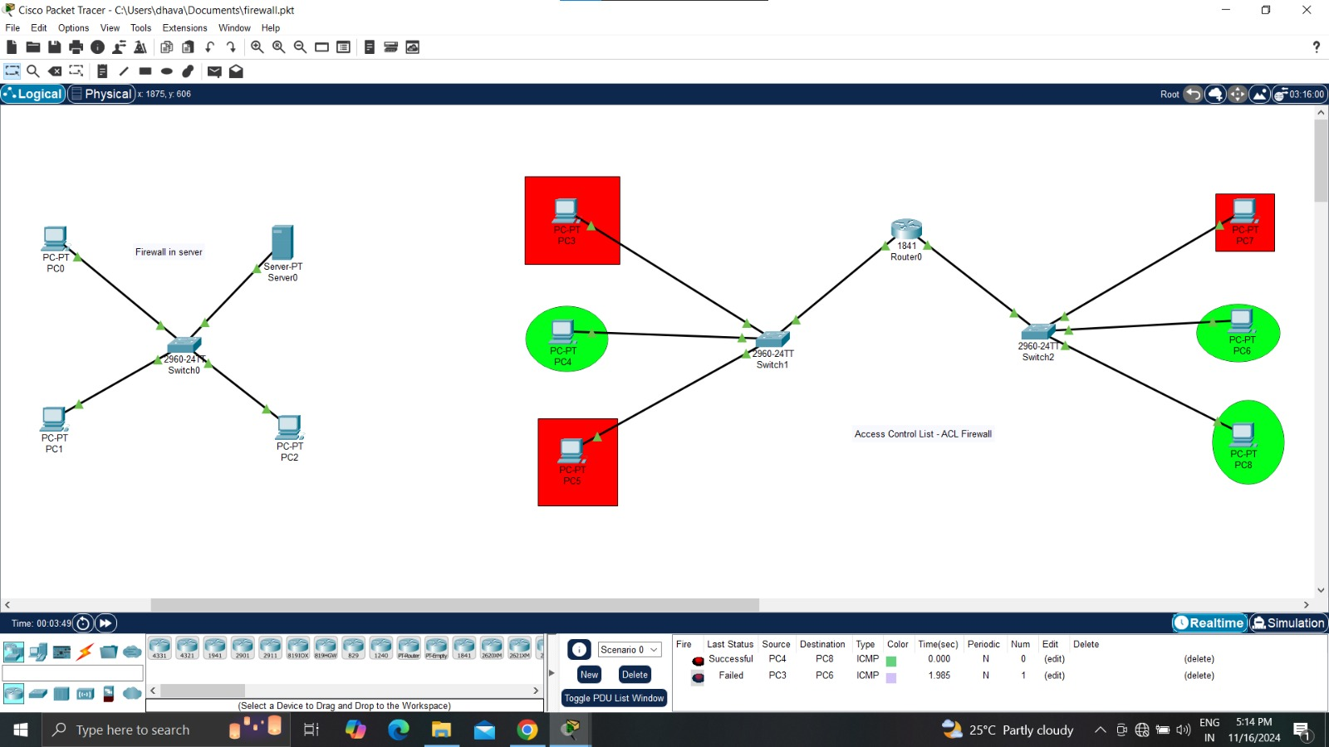

ROUTER CONFIGURATION

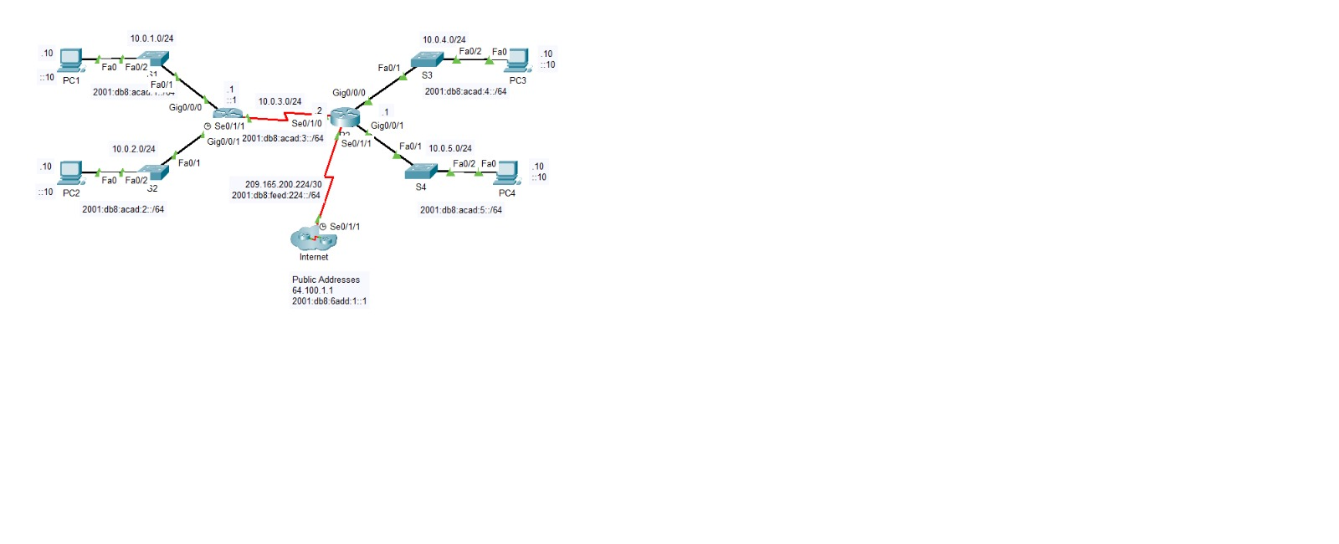

TOPOLOGIES

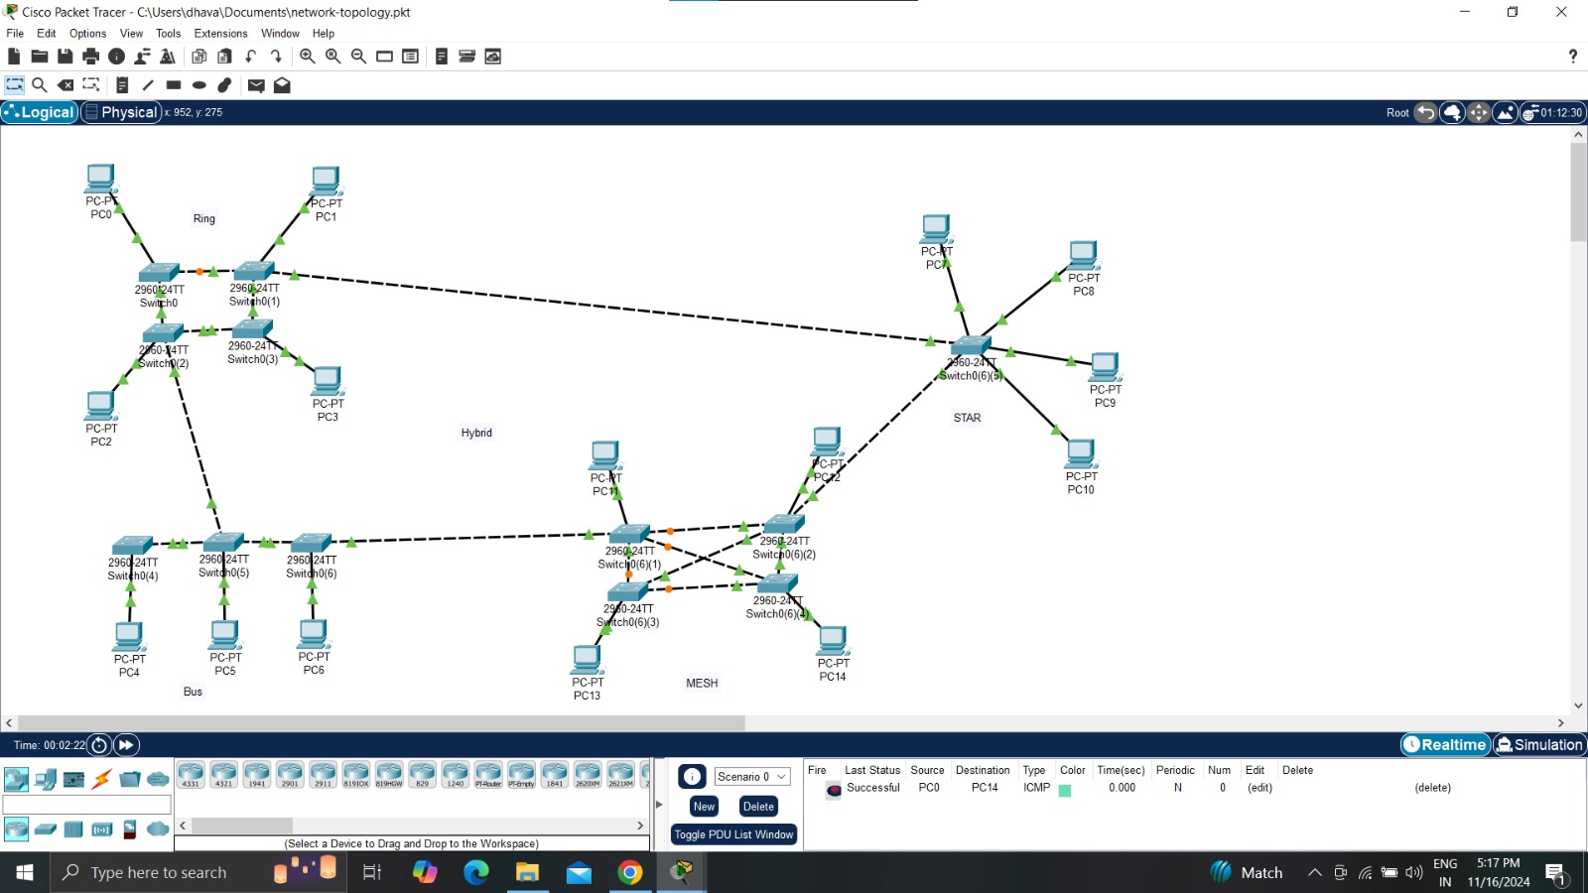

VLAN CONFIGURATION

